
MEMORANDUM

To: | Charlie Refvem, Lecturer, Department of Mechanical Engineering, Cal Poly SLO
 | crefvem@calpoly.edu
From: | Jake Rowen
 | jhrowen@calpoly.edu
Team:  Date: | N/A  1/11/26
RE: | ME 405 HW 0x00

Table of Contents
- Plot
- Transcript of Rejected Lines
- Code attachment

Plot

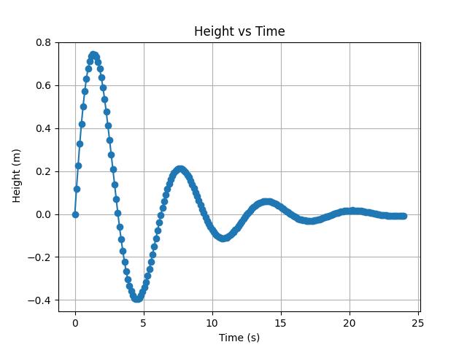

Transcript of Rejected Lines

Empty line found on line 6, skipping line.
Comment found on line 7
Invalid data on line 7, skipping line.
Empty line found on line 8, skipping line.
Invalid data on line 12, skipping line.
Comment found on line 86
Invalid data on line 86, skipping line.

Code attachment

from matplotlib import pyplot as plt

with open('data.csv', 'r') as data:
items = data.readlines()
headers = items[0].strip().split(',')

data = []
for i in range(1, len(items)):
values = items[i].strip().split(',')
subvalues = []
for val in values:
if '#' in val:
subvals = val.partition('#')
for subval in subvals:
if subval.strip() != '':
subvalues.append(subval.strip())
else:
subvalues.append(val)
data.append(subvalues)

clean_data = []
for i in range(len(data)):
row = []
for j in range(len(data[i])):
try:
row.append(float(data[i][j]))
except ValueError:
if len(data[i])<= 2 and (len(data[i]) == 0 or data[i][j] == ''):
print(f"Empty line found on line {i+2}, skipping line.")
continue
elif "#" in data[i][j]:
print(f"Comment found on line {i+2}")
continue
else:
print(f"Invalid data on line {i+2}, skipping line.")
continue
if len(row) >= len(headers):
clean_data.append(row)

time = [row[0] for row in clean_data]
height = [row[1] for row in clean_data]

plt.plot(time, height, marker='o')
plt.title('Height vs Time')
plt.xlabel(headers[0])
plt.ylabel(headers[1])
plt.grid()
plt.show()

